Simulation Assignment Report (SAR 2)
Course: ENGR 4321 Microcontroller and Embedded Systems
Student: Daniel Critchlow Jr.
Date: February 9, 2026

1. Project Title and Brief Description

Project Title: ESP32 Bluetooth Audio Player
This project involves recreating an intermediate-level Bluetooth-enabled audio system from the SunFounder ESP32 Starter Kit using the Wokwi simulation platform. The system transforms an ESP32 microcontroller into a wireless audio sink that receives digital signals via the A2DP profile, processes them through an internal DAC, and drives a speaker via a custom-simulated audio amplifier chip.

2. Block Diagram
A professional diagram of the system architecture follows the flow of data from the wireless source to the analog output:
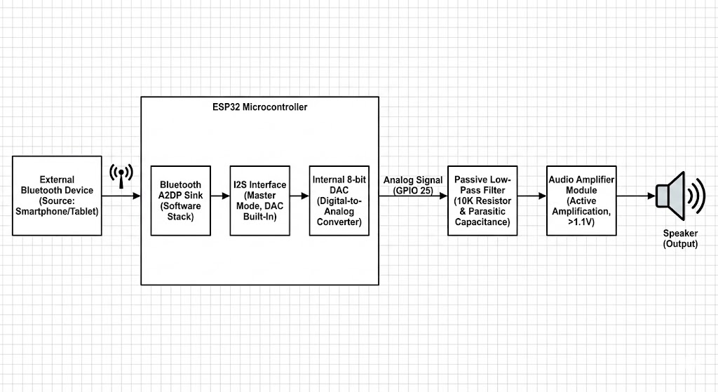

3. Links
- Wokwi Simulation: https://wokwi.com/projects/455782918003372033
- GitHub Repository: [Insert Your GitHub Link Here]

4. Source Code Explanation
The project uses the BluetoothA2DPSink library to handle the Bluetooth stack. The logic is defined by an i2s_config_t structure that sets the ESP32 to Master Mode and DAC Built-In Mode.
C++
// Key Configuration Fragment
const i2s_config_t i2s_config = {
.mode = (i2s_mode_t)(I2S_MODE_MASTER | I2S_MODE_TX | I2S_MODE_DAC_BUILT_IN),
.sample_rate = 44100,
.bits_per_sample = I2S_BITS_PER_SAMPLE_16BIT,
.channel_format = I2S_CHANNEL_FMT_RIGHT_LEFT,
.communication_format = I2S_COMM_FORMAT_STAND_MSB
};
- A2DP Sink: Manages the wireless pairing and stream buffering.
- I2S Protocol: Routes digital data internally to the 8-bit DAC.
- Custom Chip (C/JSON): Simulates the HXJ8002 amplifier by watching for pin state changes and outputting a differential signal to the speaker.

5. Discussion: System Behavior and Hardware Challenges

System Behavior
The ESP32 successfully initializes as a discoverable Bluetooth device. Once paired, it converts 16-bit PCM digital data into an analog voltage output on GPIO 25. The custom amplifier chip then boosts this 1.1V signal to drive the simulated speaker.

Hardware Challenges
A primary challenge involved pin conflicts and API mismatches within the Wokwi environment. The custom chip implementation initially failed due to a discrepancy between the provided library examples and the actual API header (wokwi-api.h). Specifically:
- API Syntax: The pin_watch function required a specific pin_watch_config_t structure.
- Field Designators: The compiler rejected .callback and .on_change fields, requiring the use of .pin_change to successfully bind the logic to the GPIO pins.
- Signal Integrity: A 10K resistor was necessary to create a low-pass filter with parasitic capacitance to suppress high-frequency digital noise during simulation.

